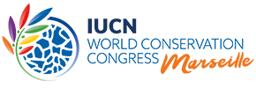
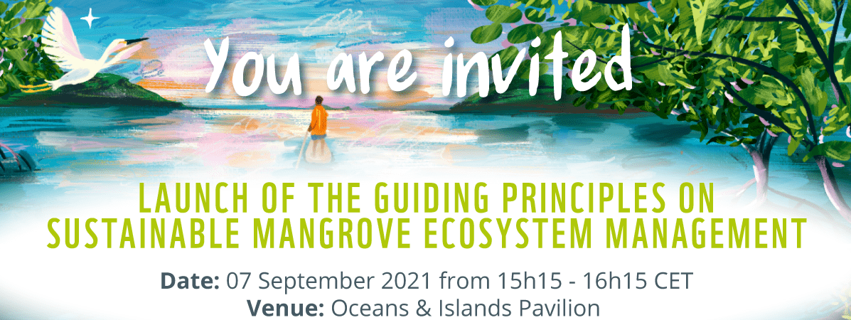
Agenda
Moderator: Dorothée Herr, Manager for Oceans and Climate Change, IUCN Global Marine and Polar Programme

1. Opening remarks on the role of mangroves for people and planet
- Hon. Ambassador Peter Thomson, UN Secretary General’s Special Envoy for the Ocean (to be confirmed)
2. Campaign #RootsOfHope
New paper-cut animation about the critical role mangroves play in protecting our oceans
- Video https://vimeo.com/580213113
Introducing the new campaign
- Mr Giuseppe di Carlo, Deputy Lead for the Ocean Practice at WWF
3. Guiding principles on sustainable mangrove ecosystem management
Introducing the new principles
- Ms Dorothée Herr, Manager for Oceans and Climate Change, IUCN Global Marine and Polar Programme
Reflections and perspectives from key partners
- Mr Wolfram Morgenroth-Klein, Head of Division at the German Federal Ministry for Economic Cooperation and Development (BMZ)
- Ms Julie Mulonga, Director for Eastern Africa at Wetlands International / Member of the Global Mangrove Alliance (video message)
Reflections and perspectives from country champions in the Western Indian Ocean region
- Hon. Minister Maibaze Ivete, Minister of Land and Environment, Mozambique
- Hon. Baomiavotse Vahinala Raharinirina, Minister of the Environment and Sustainable Development, Madagascar (to be confirmed)
- Hon. Mohammed Elmi, Chief Administrative Secretary for Environment and Forestry, Kenya
4. Concluding remarks and call for action
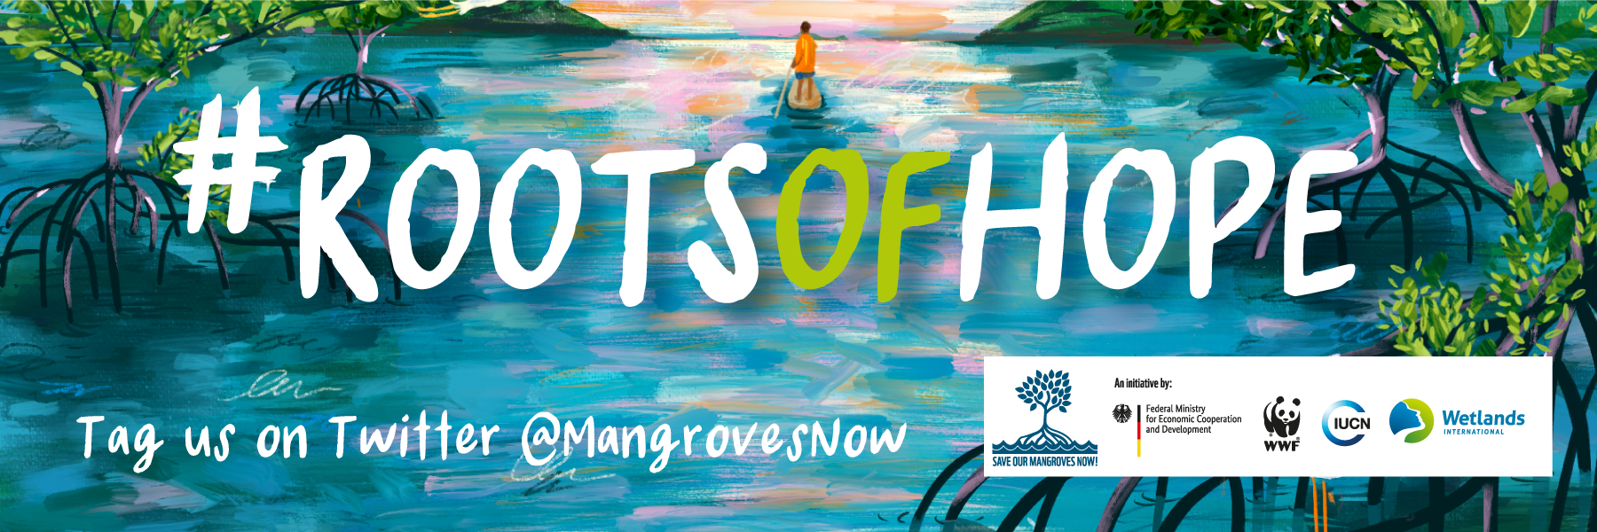
- Mr Thomas Sberna, Regional Head for Coastal and Ocean Resilience at IUCN Eastern and Southern Africa Regional Office and 2021 Young Leader of the French-African Foundation

